

**INTERNSHIP OFFER LETTER**



Date : **07/08/2023 ID:CS07WX32492**

Dear,

**Omkar Varkhade**

We would like to congratulate you on being selected for the “ **Java Programming”** internship position with “**CodSoft”**. We at **CodSoft** are excited that you will join our team.

The duration of the internship will be of **4 weeks**, starting from **10 August 2023 to 10 September 2023** The internship is an educational opportunity for you hence the primary focus is on learning and developing new skills and gaining hands-on knowledge. We believe that you will perform all your tasks/projects.

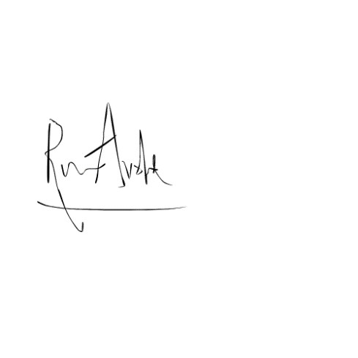

**Team**

**CodSoft**

MSME

Registered



As an intern, we expect you to perform all assigned tasks to the best of your ability and follow any lawful and reasonable instructions provided to you.

We are confident that this internship will be a valuable experience for you, we look forward to working with you and helping you achieve your career goals.

Best of Luck!

**Thank You!**